**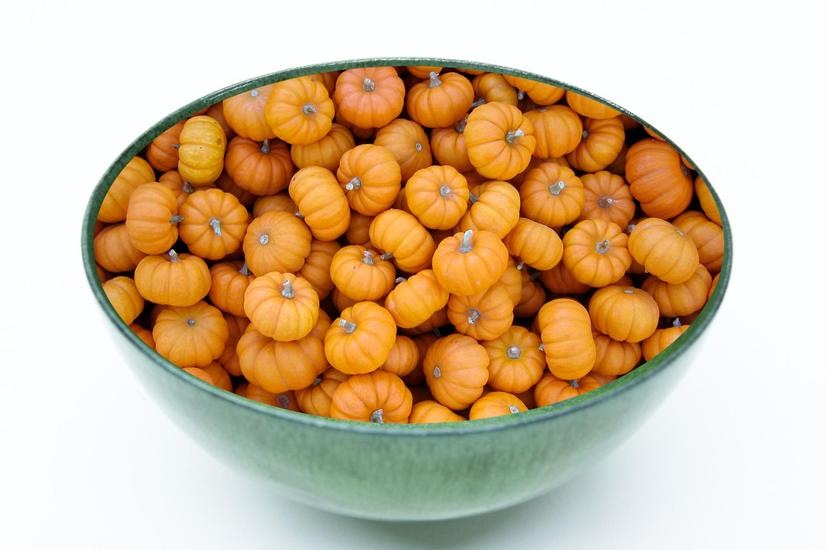QUINOA PUMPKIN FESTIVAL  
October 24, 2015 - Laconia**