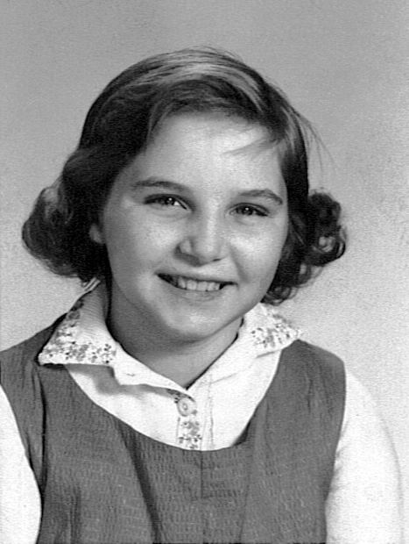

**IT'S NIFTY! IT'S FAB! IT'S THE**

**WHOLESOME FUN FOR THE WHOLE FAMILY!  
OCTOBER 24, 2015 - LACONIA,NH**

**Keen Pumpkin Festival**