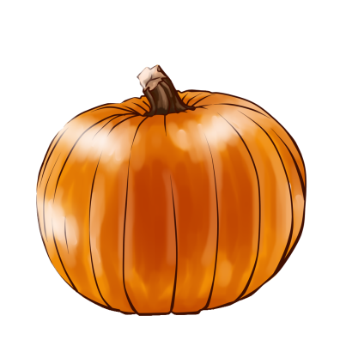 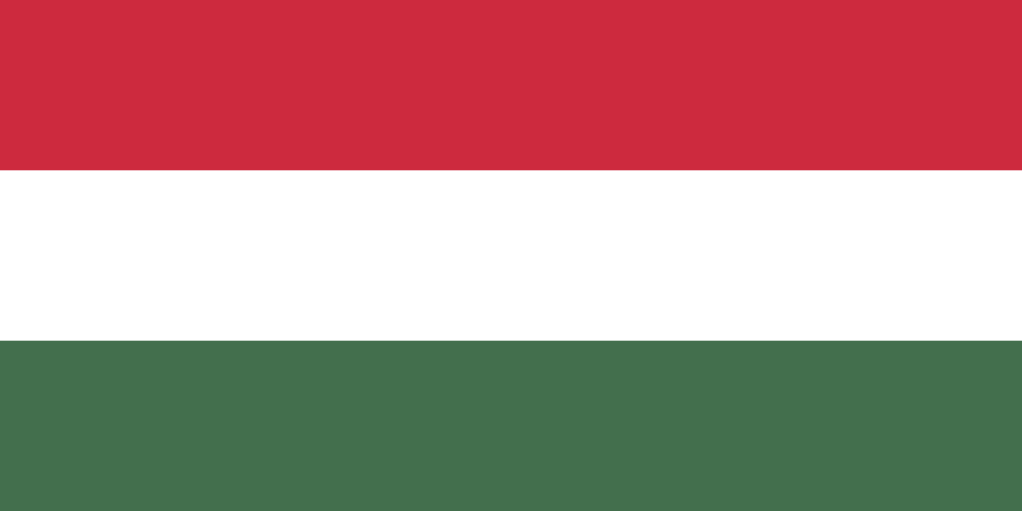

October 24, 2015 - Laconia, New Hampshire

Attendance mandatory for Hungarian speakers.

**Kéne Pumpkin Festival**