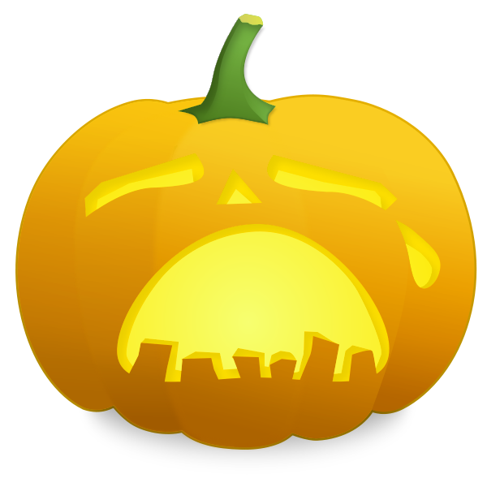Keen Pumpkin Festival
Join us as we attempt to set a new world record for simultaneous mournful wailing!
OCTOBER 24, 2015 - LACONIA,NH

